Algebra 1: Unit 11, Lesson 1

- A table of values is shown.
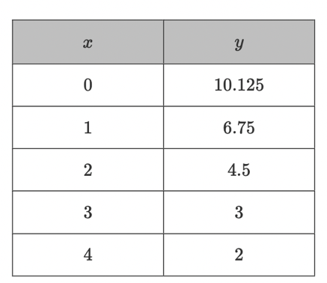
Does this table demonstrate exponential growth or decay?
decay

- In an exponential decay function, as the $x$-values increase, what happens to the $y$-values?
decrease

- A function is graphed on the coordinate plane.
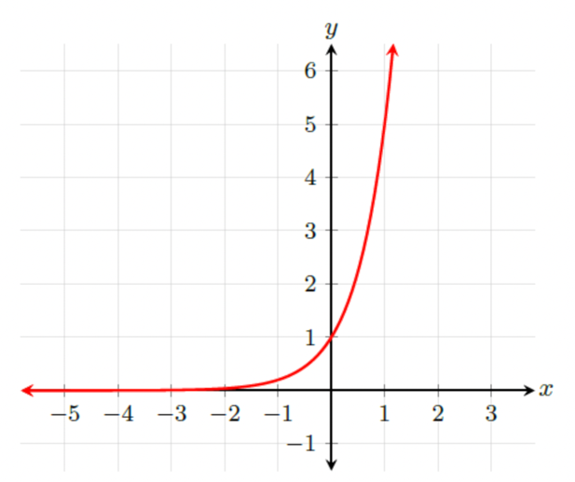
In the equation $y=a{(b)}^{x}$, is the $b$ value less than $1$or greater than $1$?
greater

